## Steps to Create an AIRFLOW Cluster in AWS

1. Create a S3 bucket.
2. Inside that bucket create 2 folder
   1. Dags
   2. Requirements
   3. Add the python code inside on the Dags folder || And ADD the requirements.txt in the Requirements Folder
3. Open the Managed airflow service on AWS & CLICK ON Create Environment.
4. Click on Create Environment.
5. And select the buckets as shown below

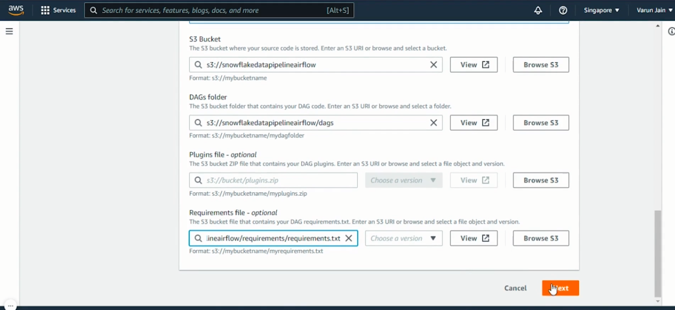

1. Click on NEXT and THEN CLICK ON Create MWAA VPC
2. Change the Stack name accordingly and Click on CREATE STACK
3. Once the STACK IS created select the same one while creating the AIRFLOW CLUSTER ENVIRONMENT.

As shown below

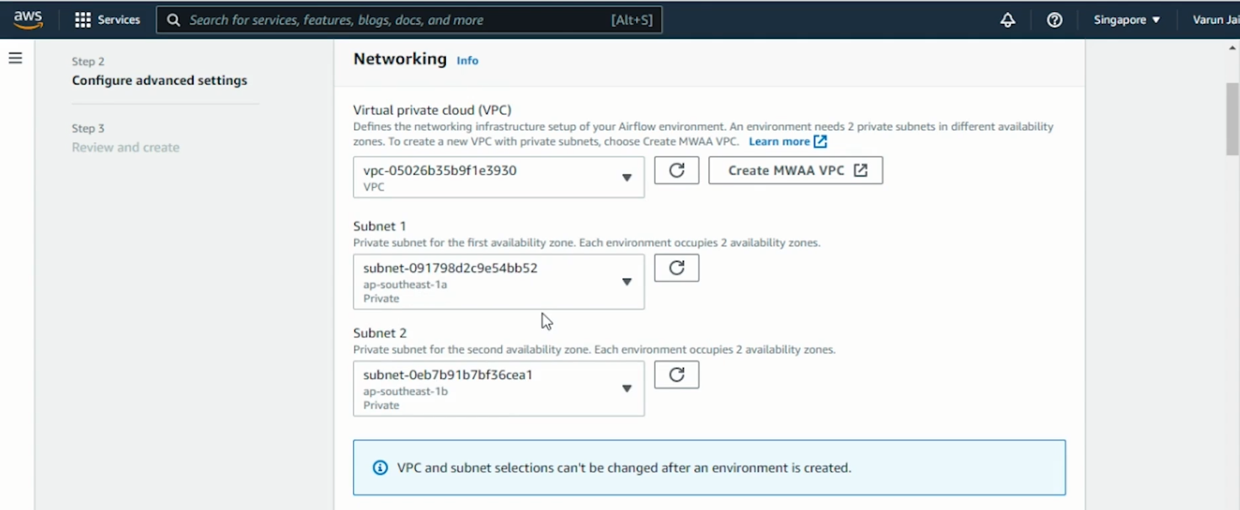

1. SELECT PUBLIC NETWORK
2. KEEP EVERYTHING DEFAULT
3. ONCE YOU REACH BELOW TO IAM SETTING CREATE A IAM ROLE WITH ALL THE LISTED POLICIES as shown below

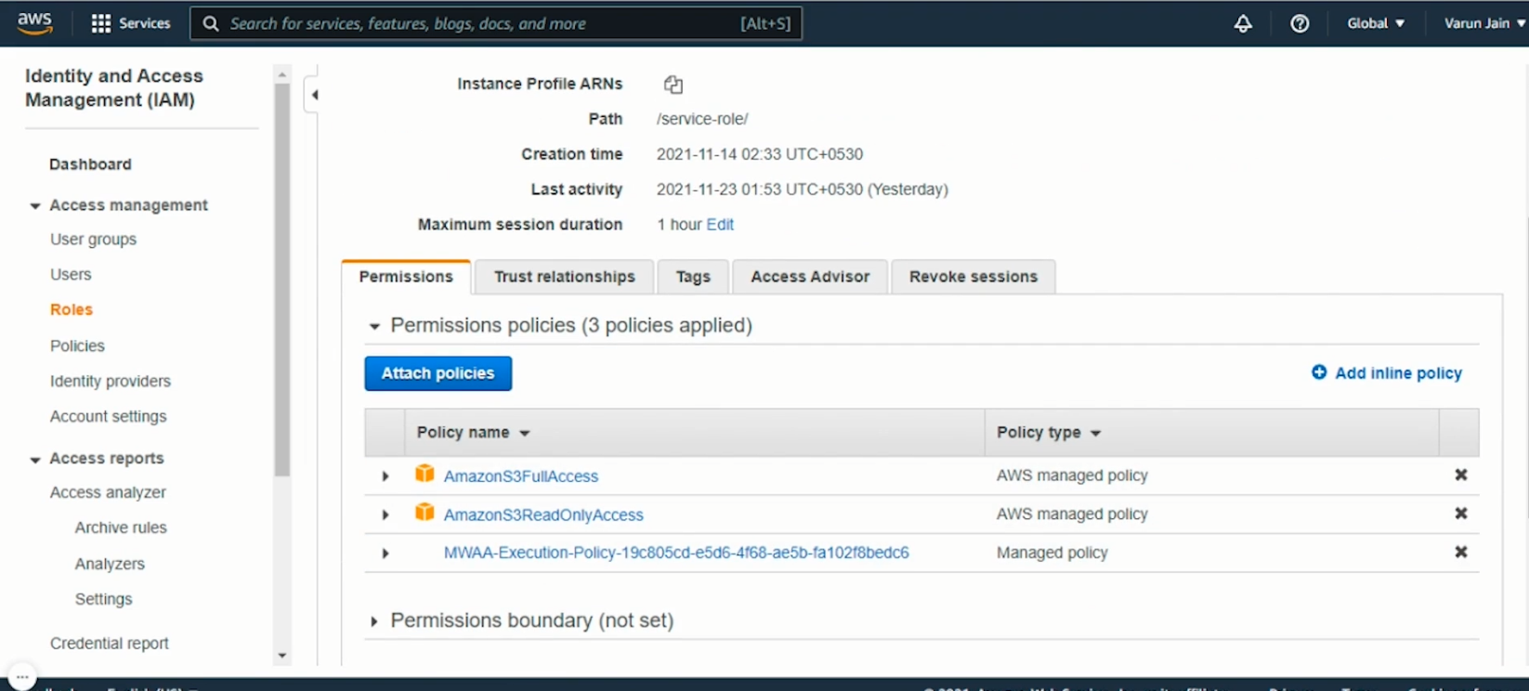

1. CLICK NEXT
2. CLICK ON CREATE ENVIRONMENT